**Report for Thelook Ecommerce Dataset**

**User_Table:**

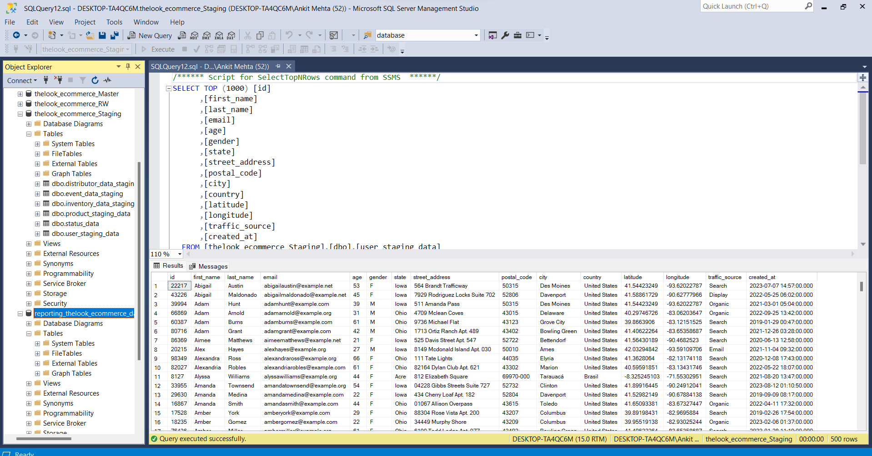

Sql table view.

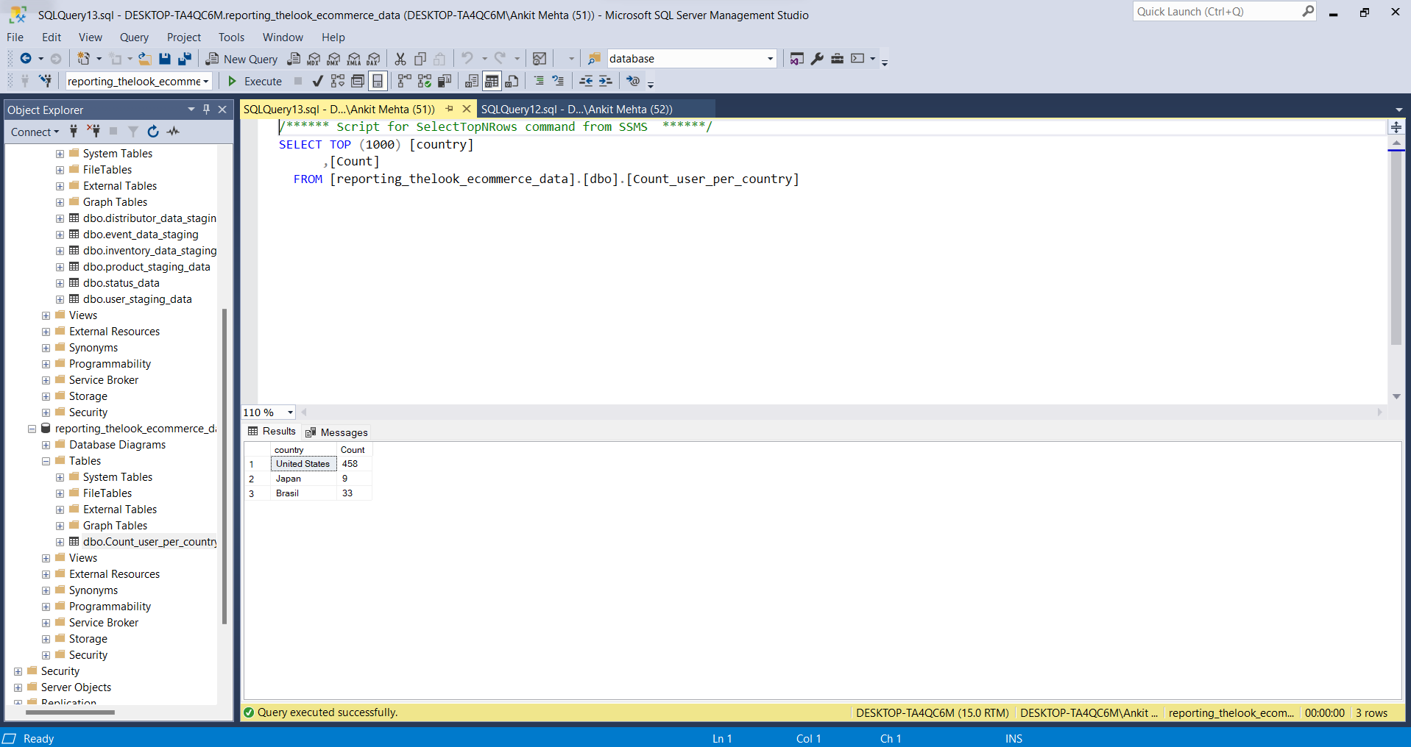For the given dataset there are:

Country Count

United States: 458

Japan: 9

Brasil: 33

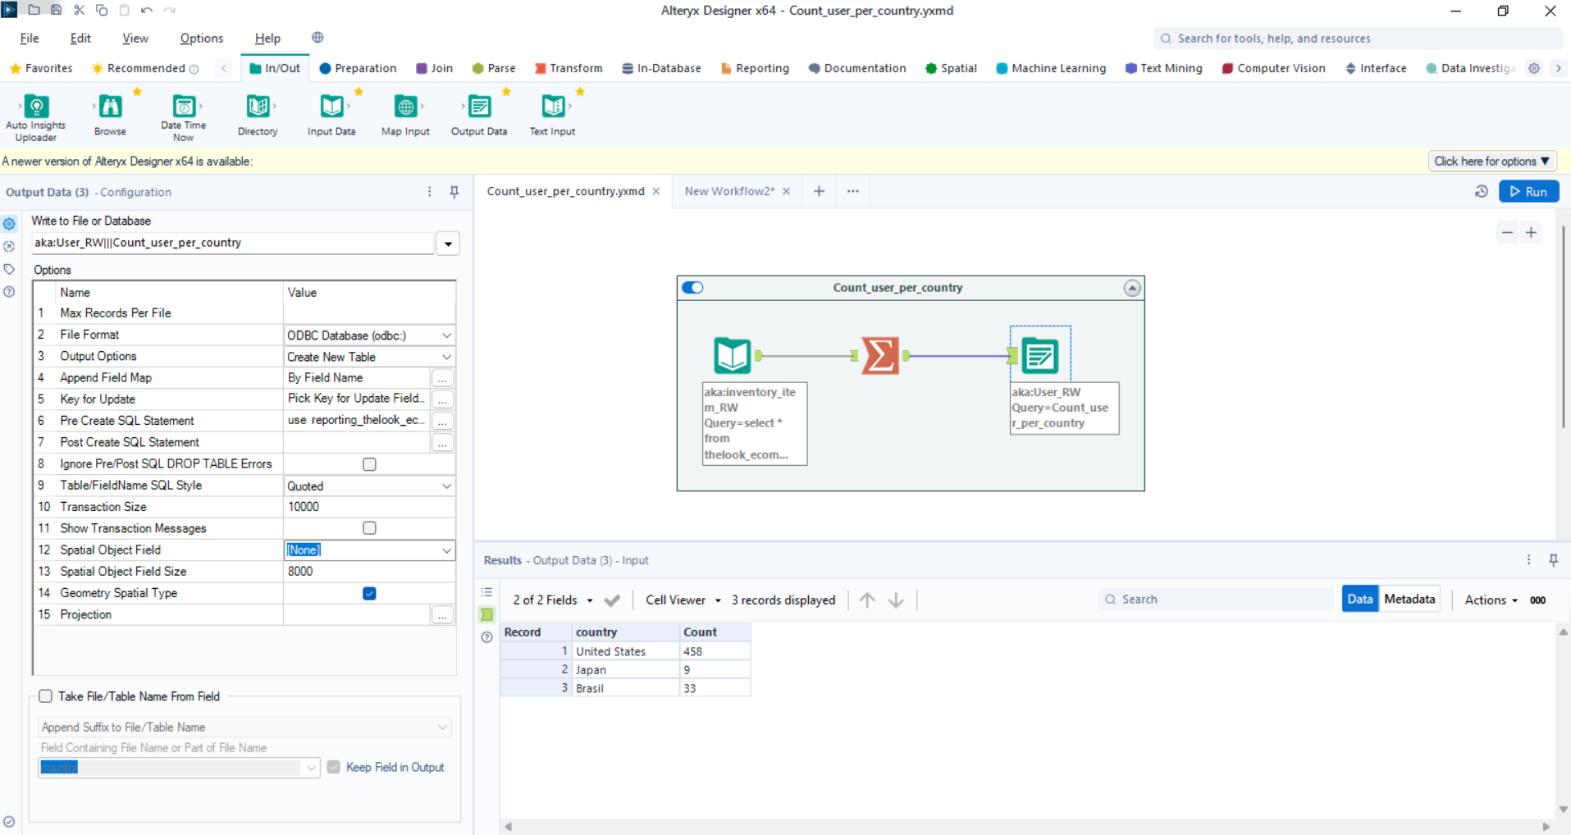

Alteryx workflow for counting and ETL processing for this table.

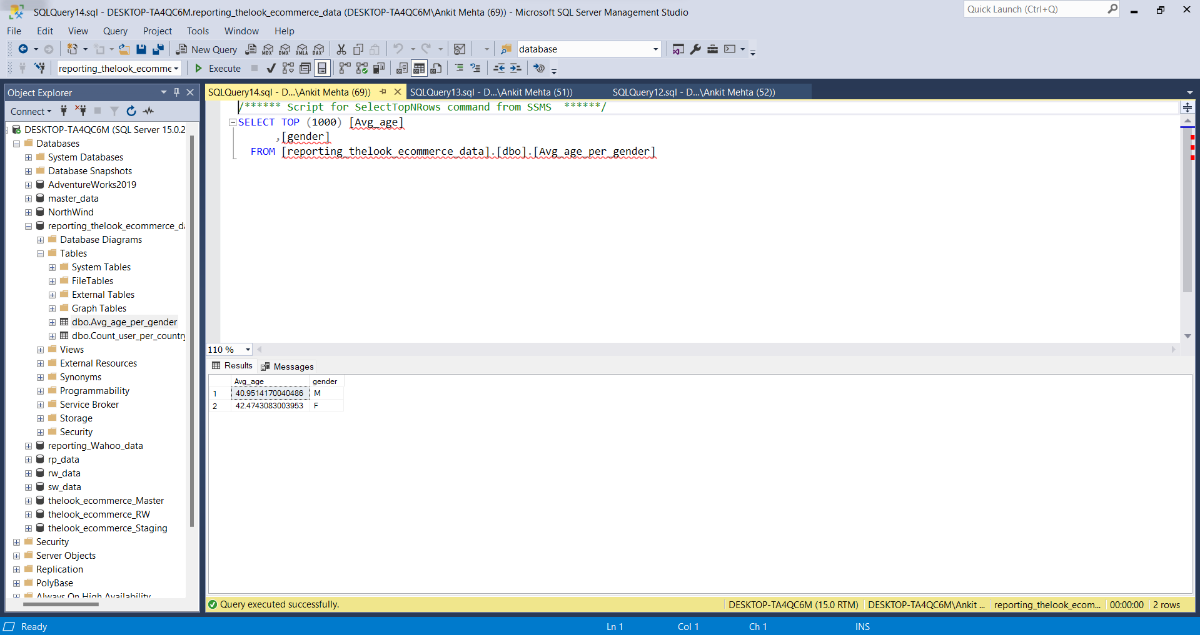

For the given dataset average age regarding gender:

Avg_age gender

40.9514170040486 M

42.4743083003953 F

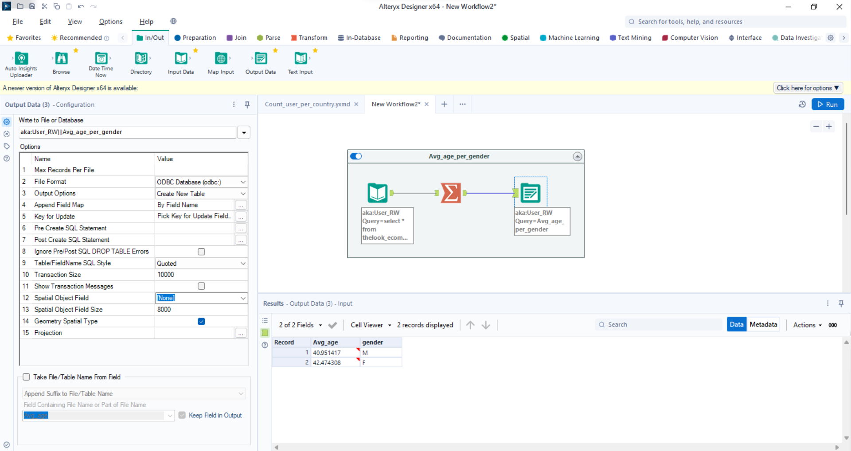

Alteryx workflow for calculating Average age per gender and ETL processing for this table.

**Event_table:**

**Inventory_table:**

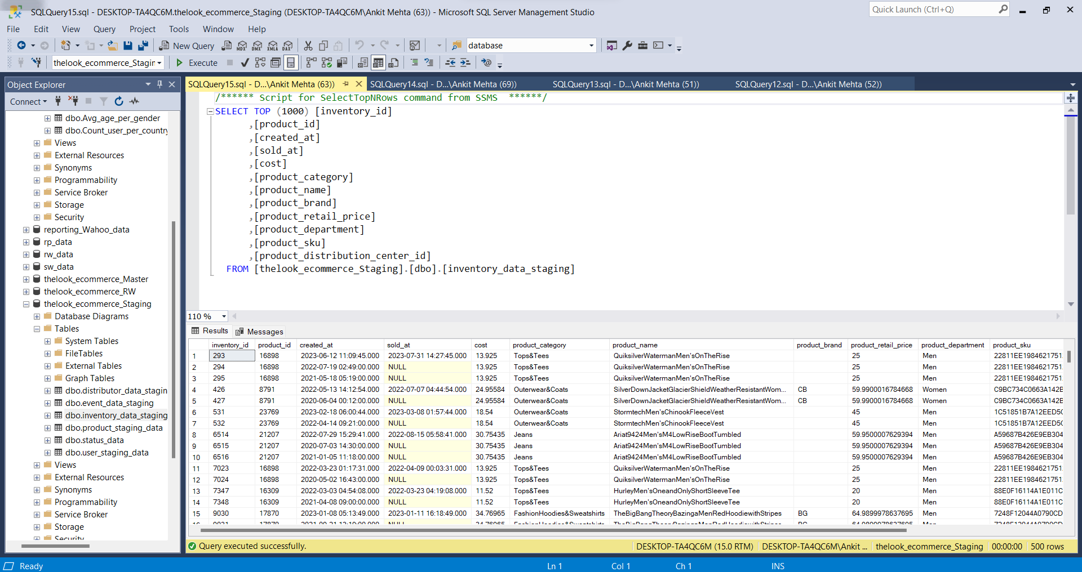

Sql table view.

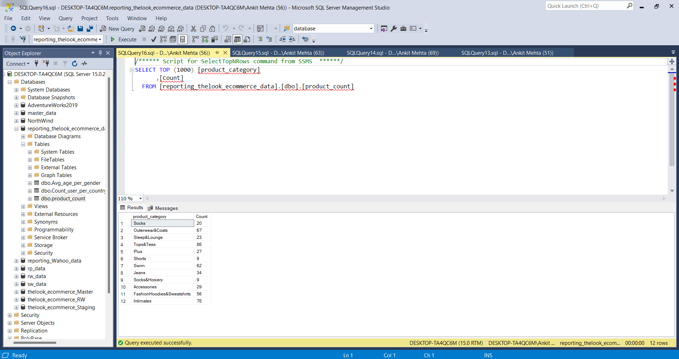

For dataset total count per Product_category:

product_category Count

Socks 20

Outerwear&Coats 67

Sleep&Lounge 23

Tops&Tees 86

Plus 27

Shorts 9

Swim 62

Jeans 34

Socks&Hosiery 9

Accessories 29

FashionHoodies&Sweatshirts 56

Intimates 78

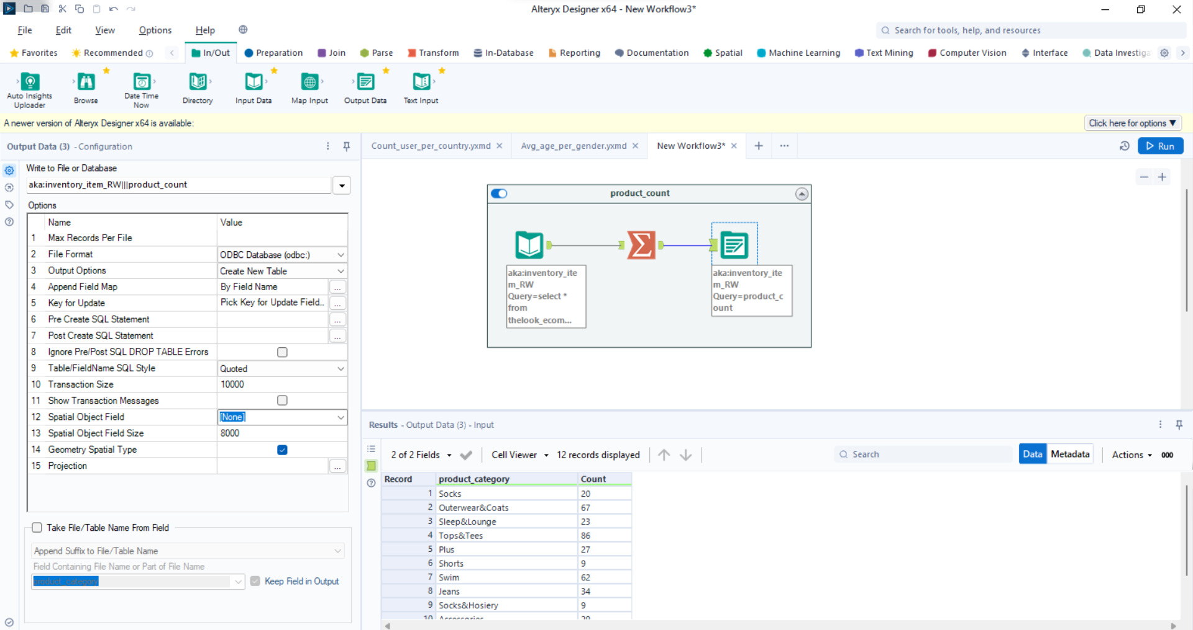

Alteryx workflow for calculating total count per Product_category and ETL processing for this table.

**Product_table:**

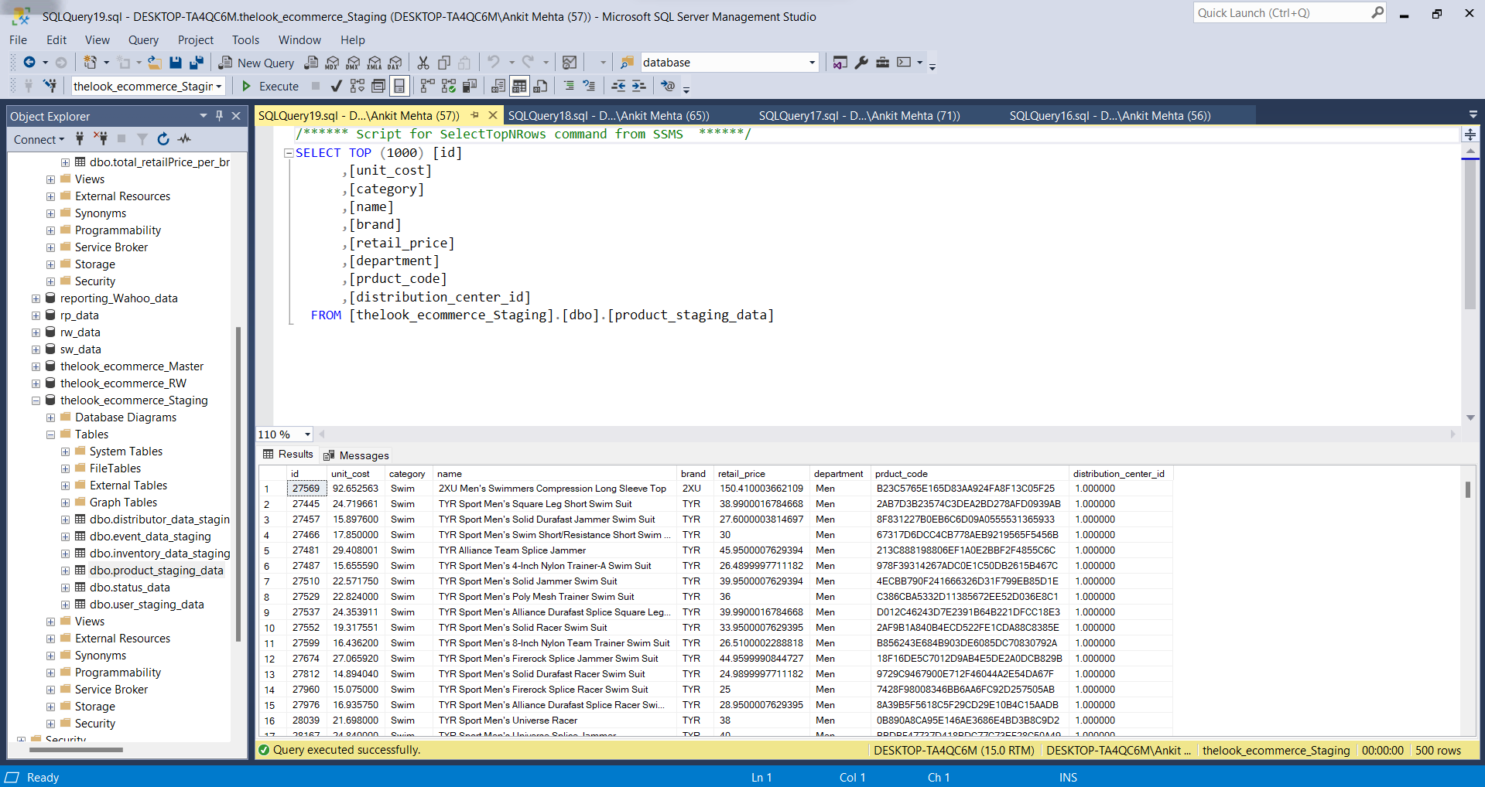

Sql table view.

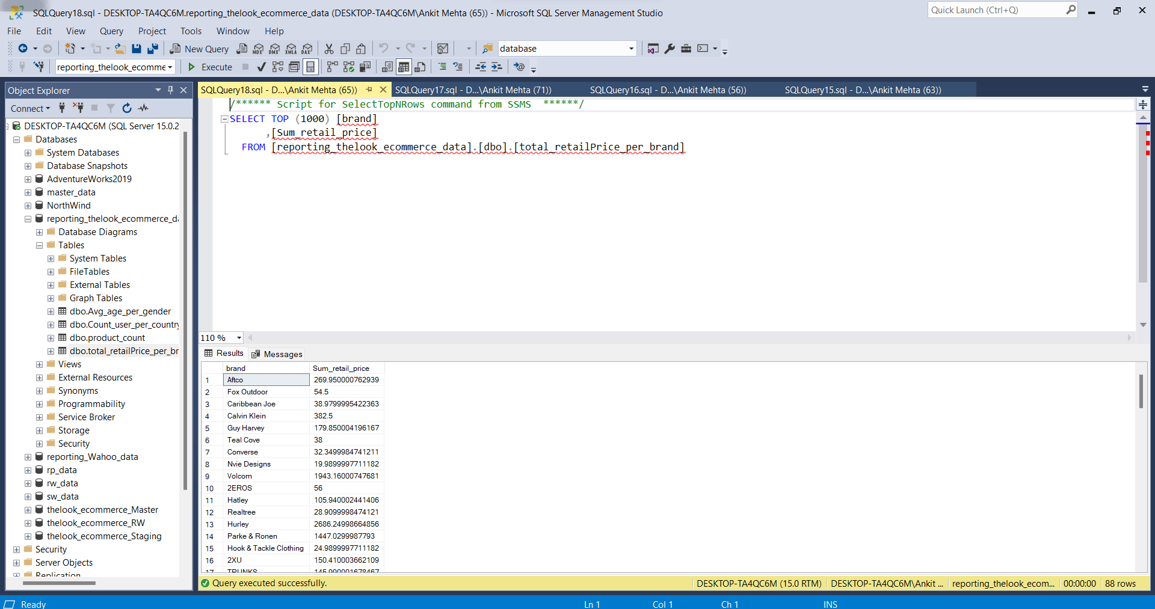

For Given dataset totalRetails price per brand:

brand Sum_retail_price

Aftco 269.950000762939

Fox Outdoor 54.5

Caribbean Joe 38.9799995422363

Calvin Klein 382.5

Guy Harvey 179.850004196167

Teal Cove 38

Converse 32.3499984741211

Nvie Designs 19.9899997711182

Volcom 1943.16000747681

2EROS 56

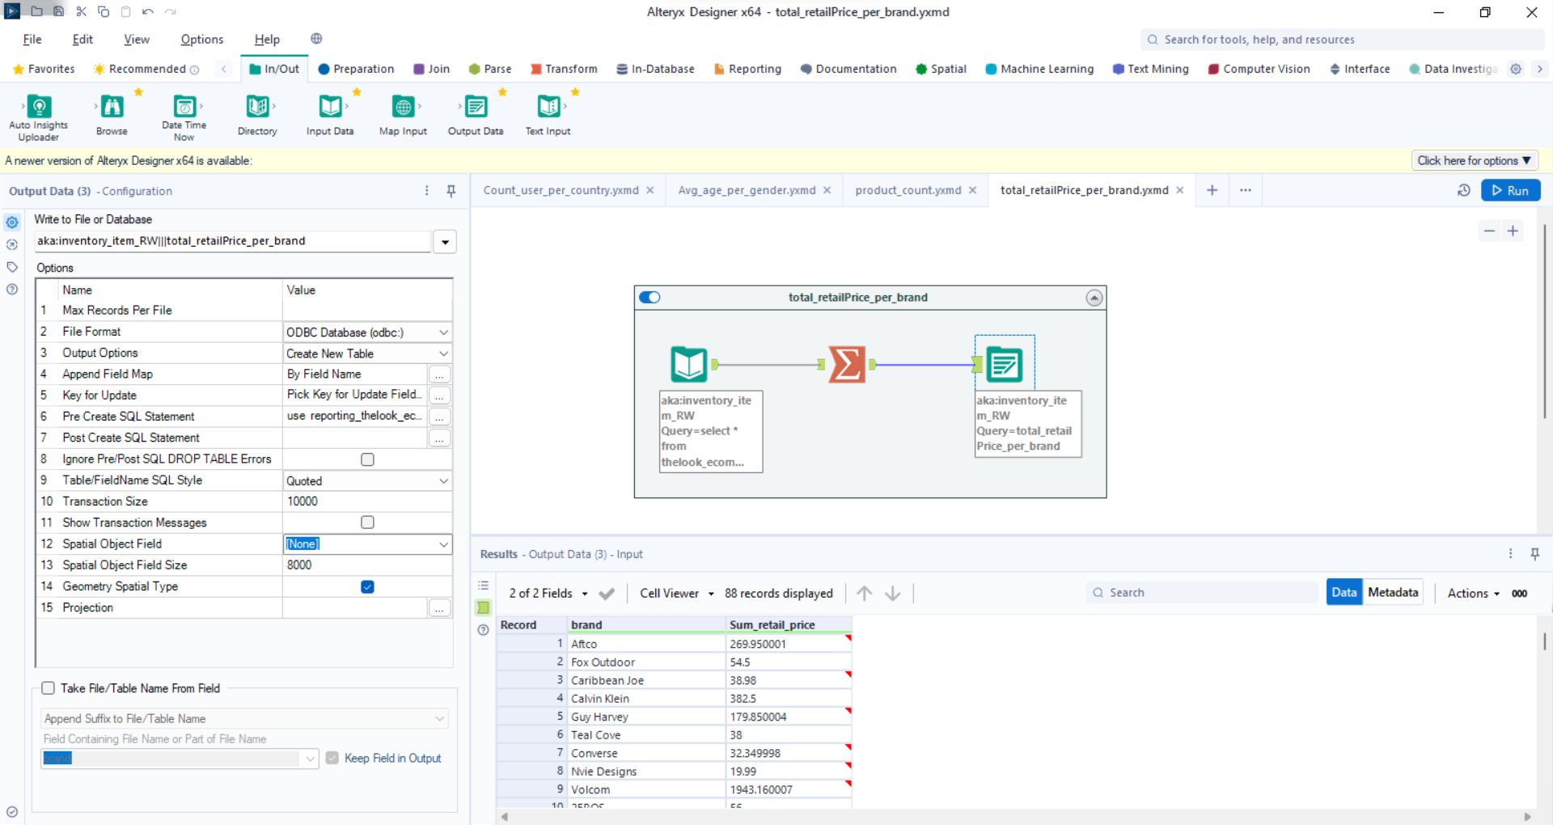

Alteryx workflow for calculating total RetailPrice per Brand and ETL processing for this table.

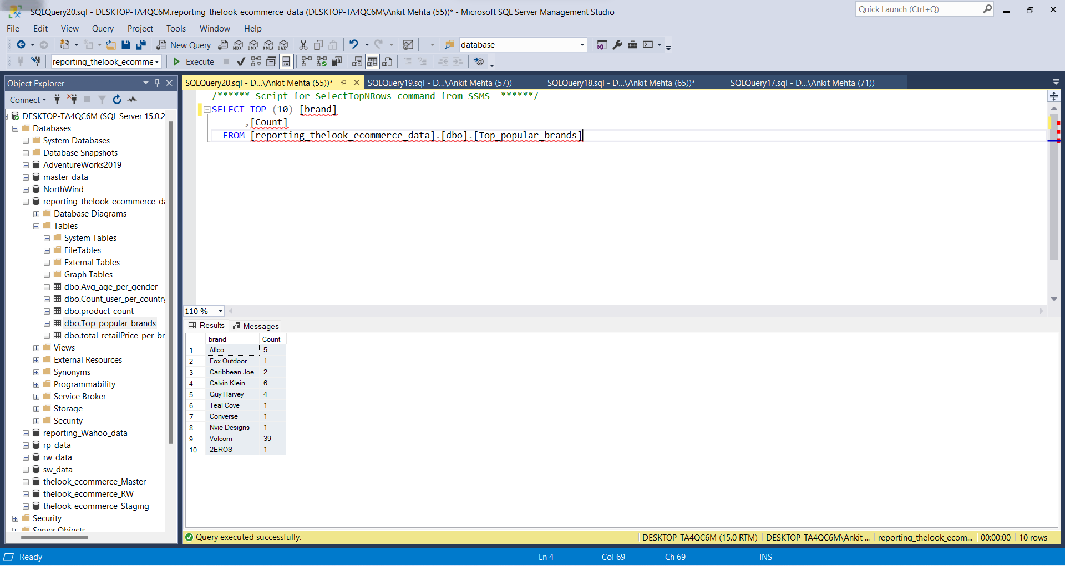

Top 10 Polpular Brands:

brand Count

Aftco 5

Fox Outdoor 1

Caribbean Joe 2

Calvin Klein 6

Guy Harvey 4

Teal Cove 1

Converse 1

Nvie Designs 1

Volcom 39

2EROS 1

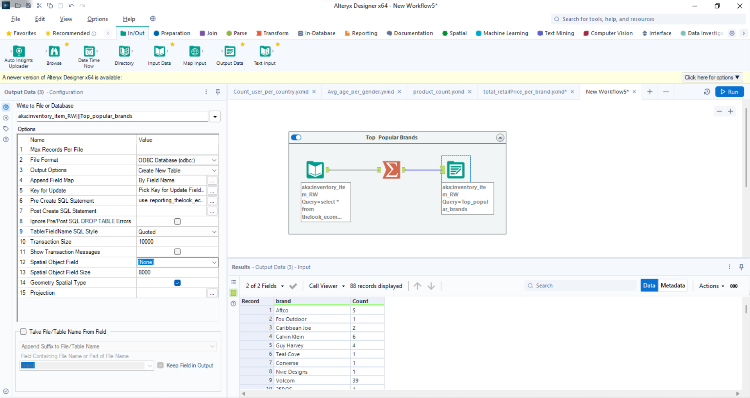

Alteryx workflow for Top popular Brands and ETL processing for this table.

**Conclusion:**

This report provides an overview of the Thelook Ecommerce Dataset, including information on user demographics, product categories, brand performance, and popularity. It includes SQL table views for each dataset and highlights key statistics and insights from the data. Additionally, Alteryx workflows are described for data processing and analysis. If more specific details or analysis are needed, please let me know.